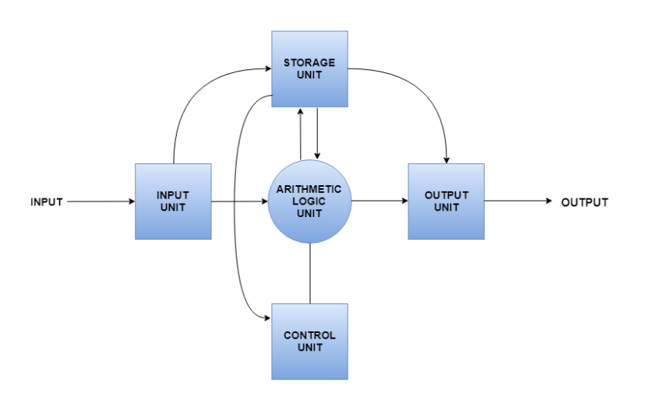
1) INPUT UNIT

Provides data to the computer system.Takes data from input devices and converts into machine language and loads into the computer system.

2)OUTPUT UNIT

Provides the results of computer process to the user.

3)STORAGE UNIT
Storage unit contains many components divided into Primary storage and secondary storage.
- Primary Memory
Also known as the main memory which is directly accessible by the cpu.
- Secondary Memory
Secondary Memory is not directly accessible by the cpu and would need to be brought into the main memory to be accessible by the cpu.

4)ALU( Arithmetic Logic Unit)
Calculations related to the computer system are performed by the ALU.
The CU( Control Unit) sends data from the storage unit to the ALU in order to perform calculations.

5)Control Unit( CU)

Controls all other units in the computer system and so is also known as the central nervous system of a computer system.
The CU dictates how memory and input output devices should behave in a computer system.

The CPU mainly comprises of the ALU and CU.

CORE
=====

Acore/ cpu core is also known as the brain of the CPU
It recieves instructions and performs calculations in order to satisfy the instructions.
Each CPU core can perform operations independently.
Multiple cores can be used to perform parallel operations.

VIRTUAL CORE

Virtual core is a cpu core which is divided into 2 areas of processor.
Virtual cores take up some of the processing without interfering with the other half.

Hyper Threading technology creates two virtual processing cores for each physical core present in the cpu.

PHYSICAL CORE

The physical core is present physically inside the chip.
Each physical core has a cache.

The number of logical cores can be determined by how many threads can be processed at the same time.

MEMORY
========

RAM

Read write memory or also known as the main memory.
Contains programs that are required by the CPU during the execution of a program.
It is volatile in nature (i.e. The data is lost once the power is turned off)

RAM can be classified into two types

1)SRAM

The data is stored statically which means it does not need to be refreshed unlike in the case of DRAM.
Data is accessed randomly regardless of the memory location that was accessed earlier.
SRAM is used as cache memory in the CPU.

Advantages->Faster Data Access, Doesn’t need to be refreshed.
Disadvantages-> Expensive, Volatile in nature, low storage capacity.

2)DRAM

The data is stored dynamically and needs to be refreshed in order to retain the data.
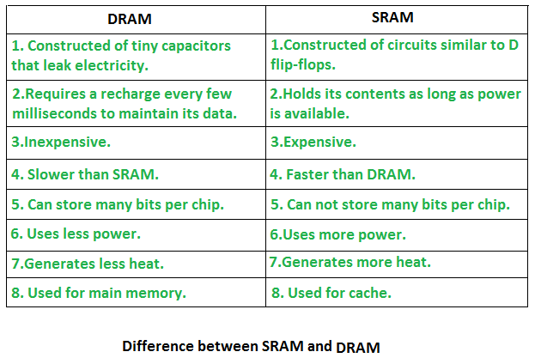

ROM

Stores crucial information essential to operate the system, like the program essential to boot the computer.
- It is non-volatile.
- Always retains its data.
- Used in embedded systems or where the programming needs no change.

VIRTUAL MEMORY
=================

Is a storage allocation scheme in which the secondary memory can be addressed as though it were a part of the main memory.
The size of a virtual memory is limited to the addressing schemeof the computer system.

MICRO-ARCHITECHTURE
======================

Is a hardware implementation of the ISA.

The ISA is a structure of commands and operatios used by the software to communicate with the hardware.

X86 64

Is a 64 bit processor which enables 32 and 64 bit processing with no loss in erformance.
Is developed by AMD.

GPU
===

GPU is used to provide the images in computer games. GPU is faster than CPU’s speed and it emphasis on high throughput.
Difference between CPU and GPU

S.NO | CPU | GPU
1. | CPU stands for Central Processing Unit. | While GPU stands for Graphics Processing Unit.
2. | CPU consumes or needs more memory than GPU. | While it consumes or requires less memory than CPU.
3. | The speed of CPU is less than GPU’s speed. | While GPU is faster than CPU’s speed.
4. | CPU contain minute powerful cores. | While it contain more weak cores.
5. | CPU is suitable for serial instruction processing. | While GPU is not suitable for serial instruction processing.
6. | CPU is not suitable for parallel instruction processing. | While GPU is suitable for parallel instruction processing.
7. | CPU emphasis on low latency. | While GPU emphasis on high throughput.

